
School of Computer Science, UPES, Dehradun.
Lab 20
DevSecOps Lab
B.TECH. - V Semester
Submitted to:
Dr. Hitesh Kumar Sharma
Submitted by:
Name: Ishika Mehrotra
Batch: Devops B1
Sap Id: 500124411
Roll No.: R2142230281

Lab Exercise 20
Creating a Pipeline Script

Objective: To create a pipeline script for automating build processes in Jenkins

Tools required: Jenkins

Prerequisites: None

Steps to be followed:
- Log in to the Jenkins CI tool and create a pipeline script

Step 1: Log in to the Jenkins Cl tool and create a pipeline script

- Open the browser, go to the Jenkins Dashboard by typing localhost:8080 in your browser, provide the credentials, and click the Sign in button

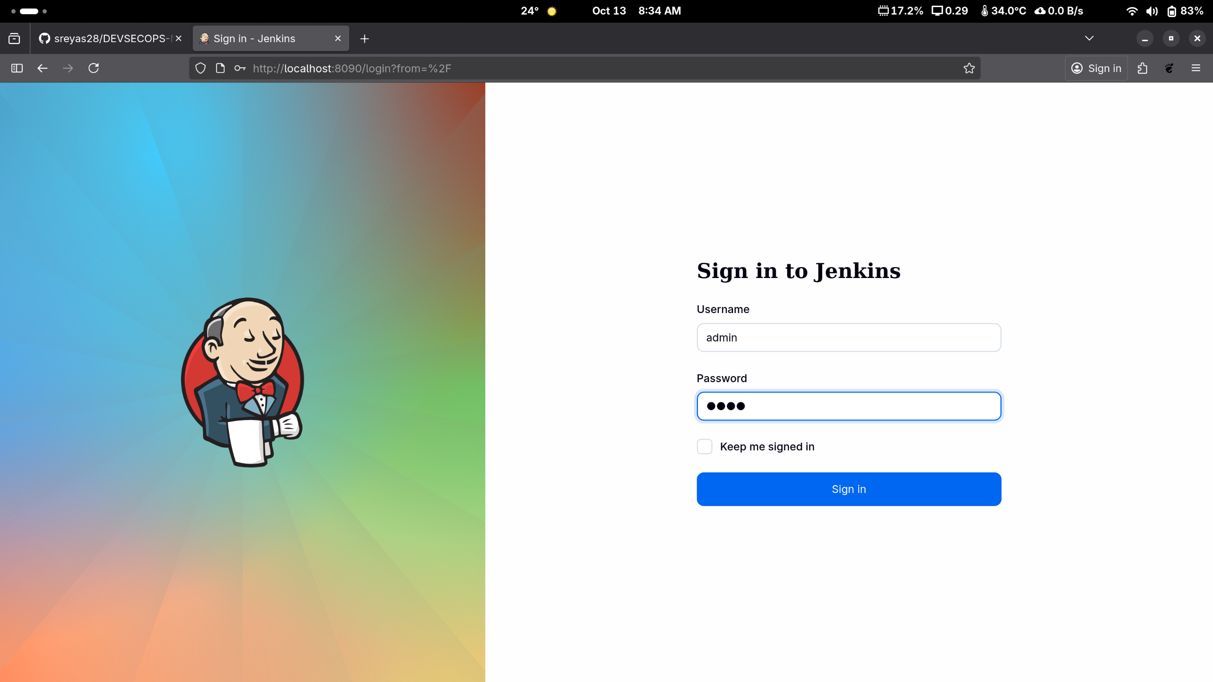
Note: The credentials for accessing Jenkins in the lab are Username: admin and Password: admin.

- Click on the New Item option as shown in the screenshot below:

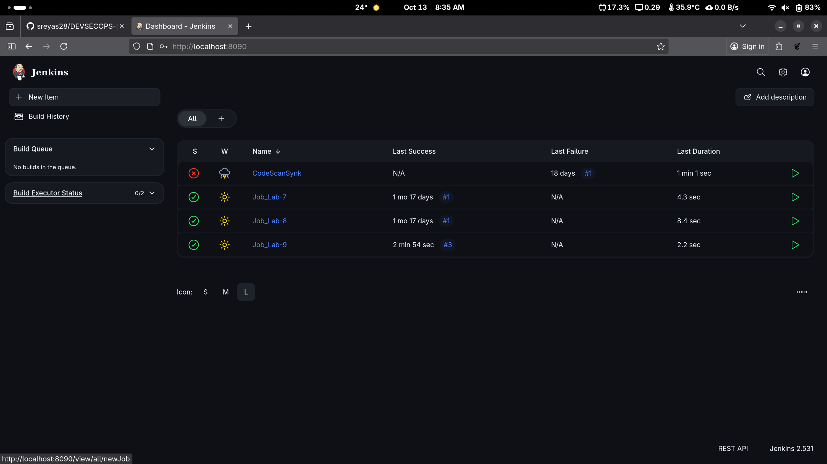

Enter a desired name for the project, select Pipeline, and then
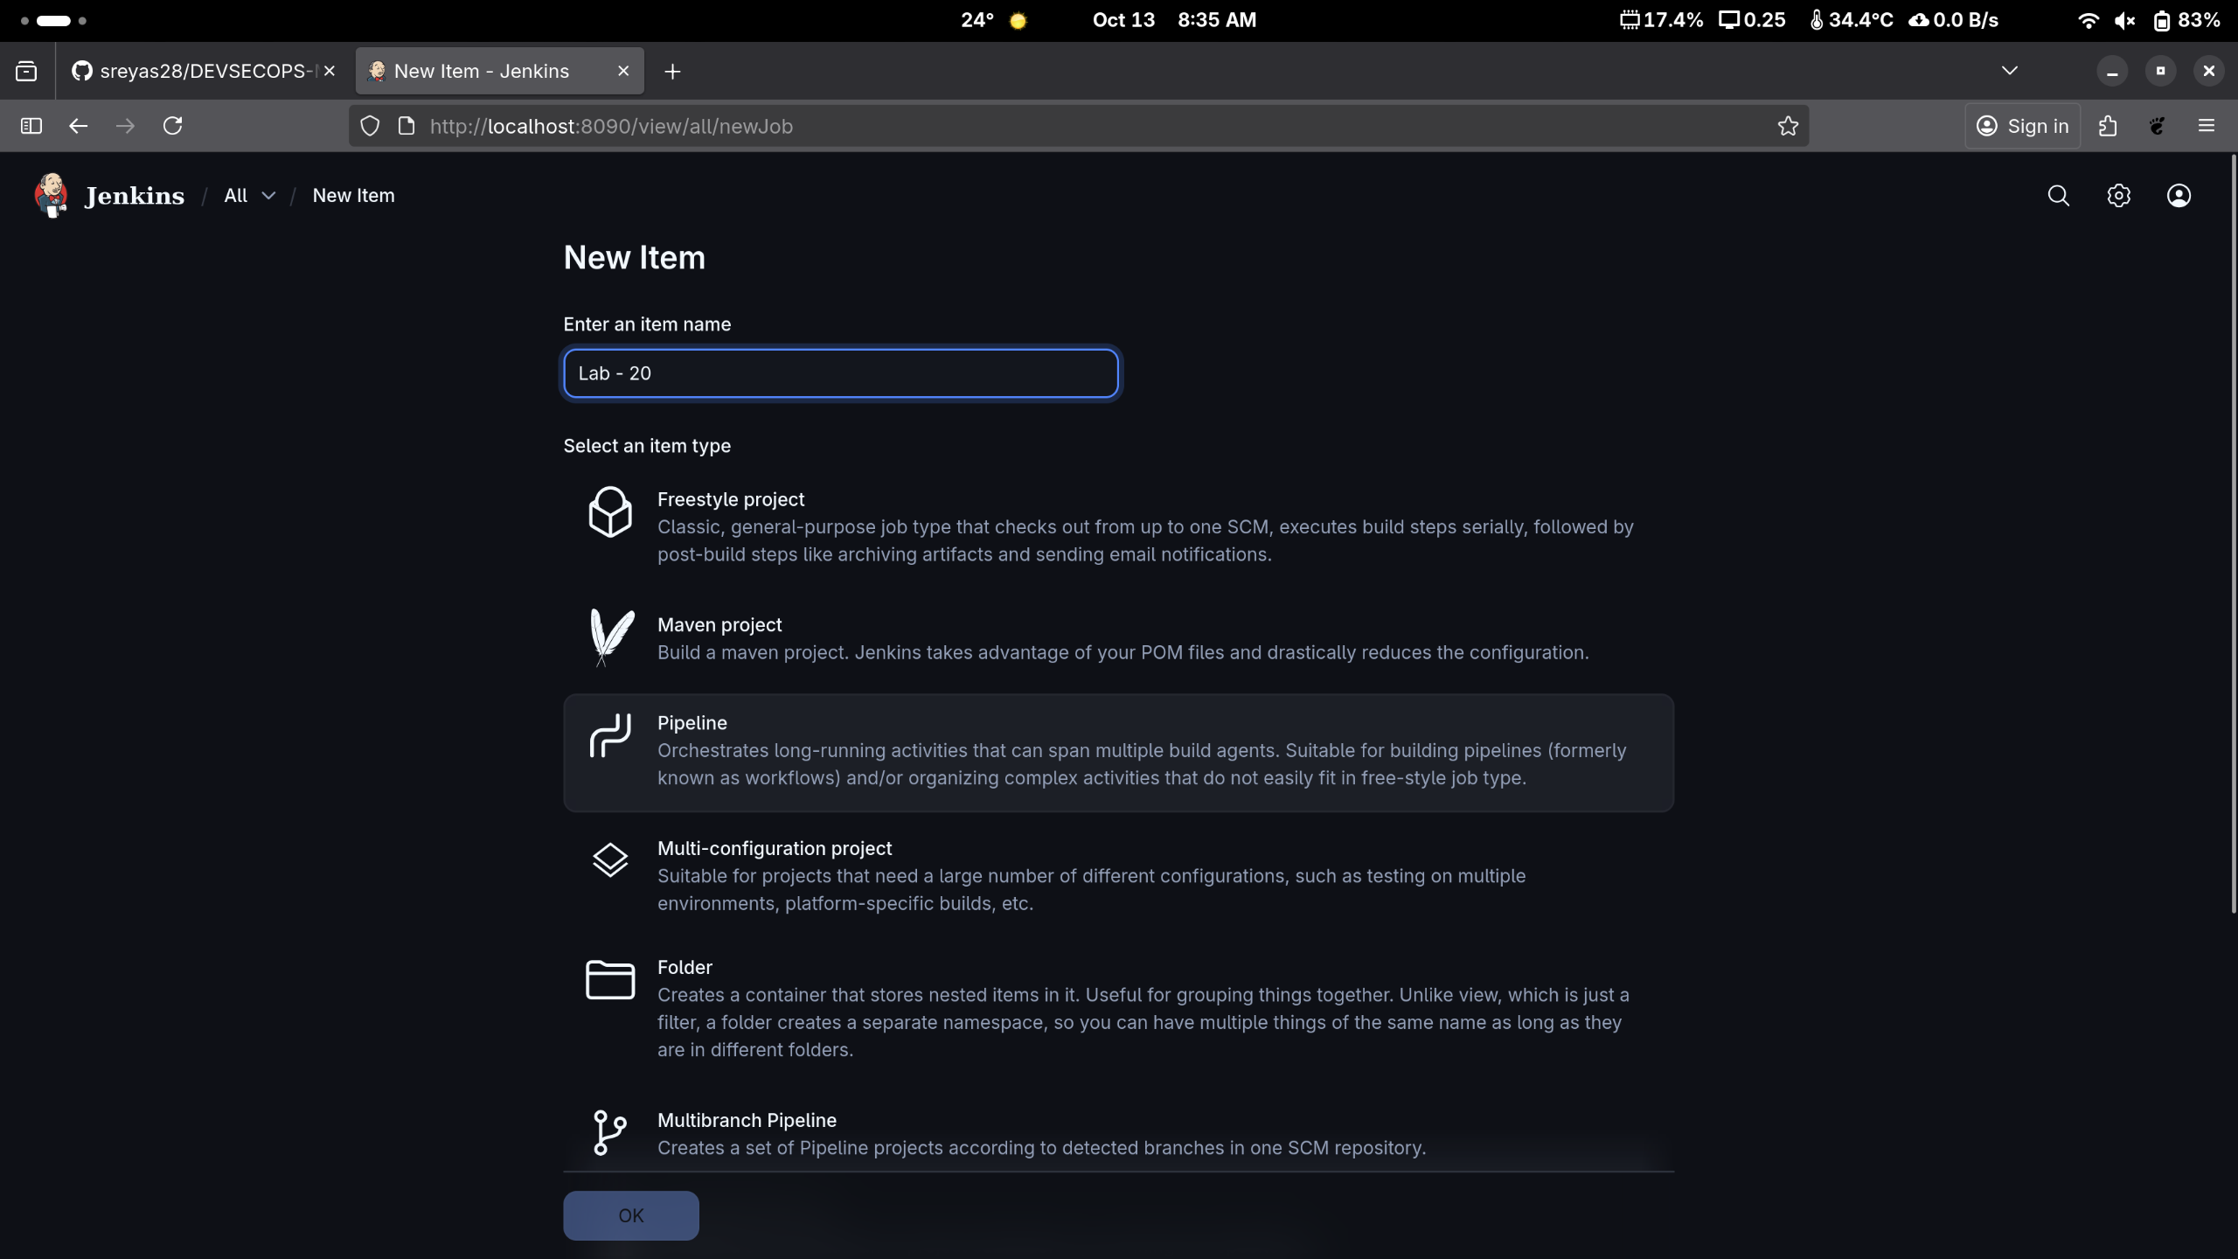
- click on OK as shown in the screenshot below:

Click on Pipeline as shown in the screenshot below:

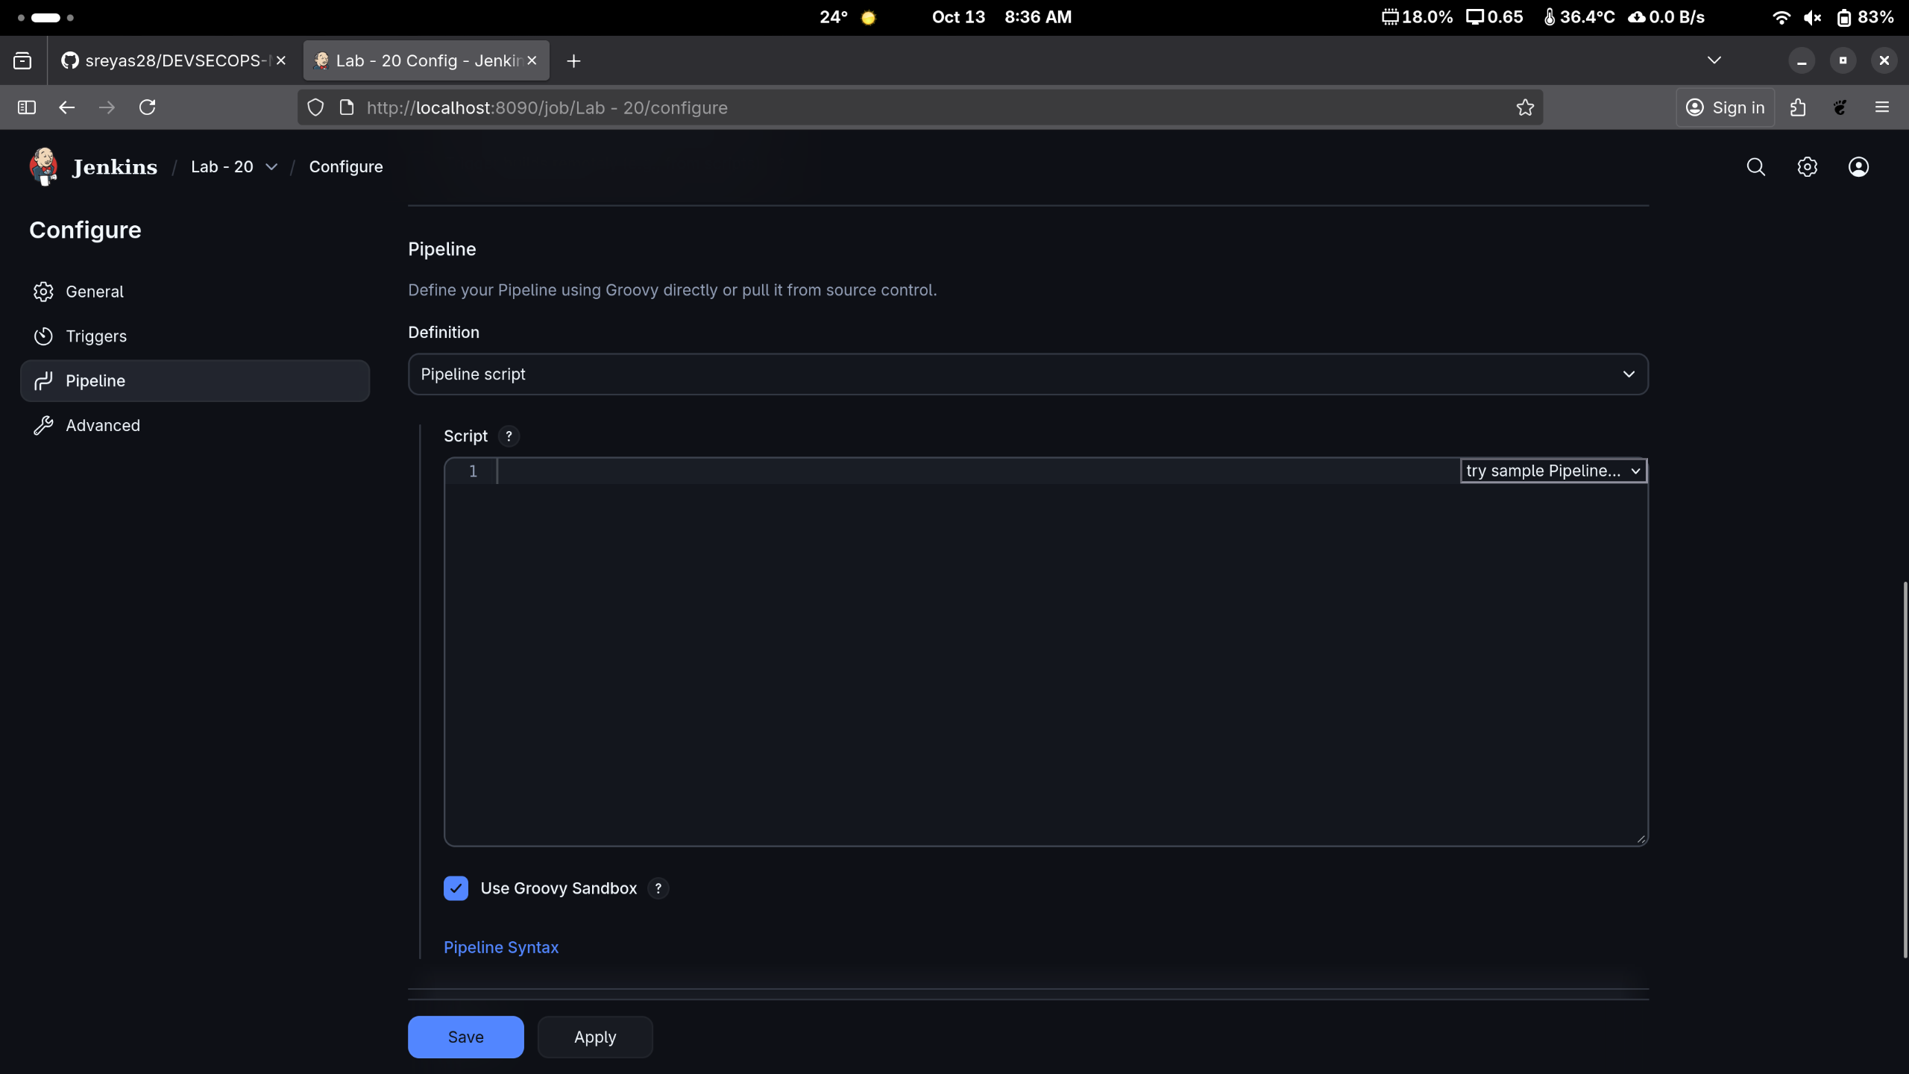

Enter the following pipeline script in the script editor and click on Save as shown in the screenshot below:
pipeline {
agent any
stages {
stage("hello") {
steps{
echo"welcome to Jenkins pipeline"
}
}
}
}

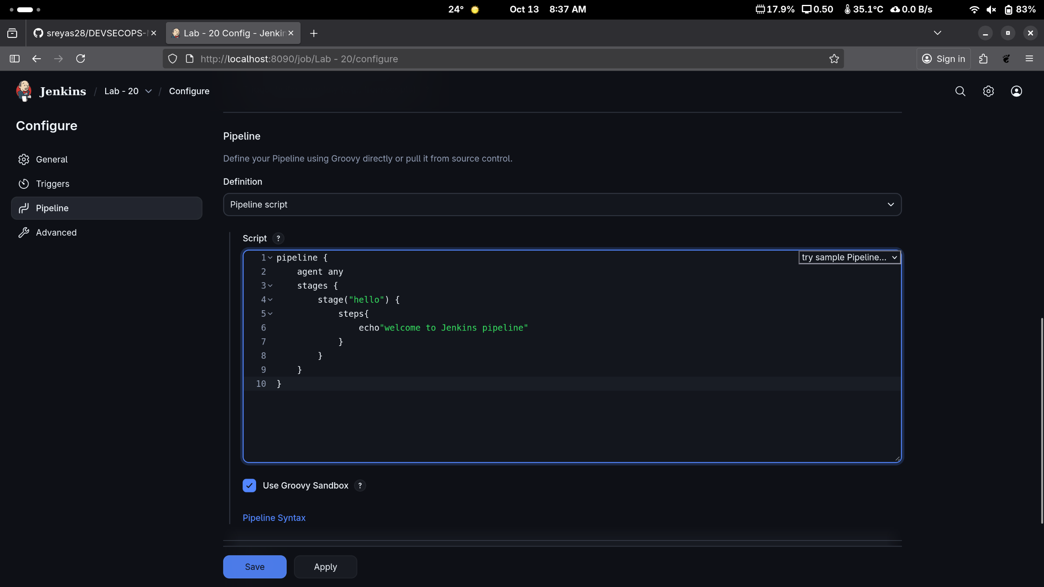

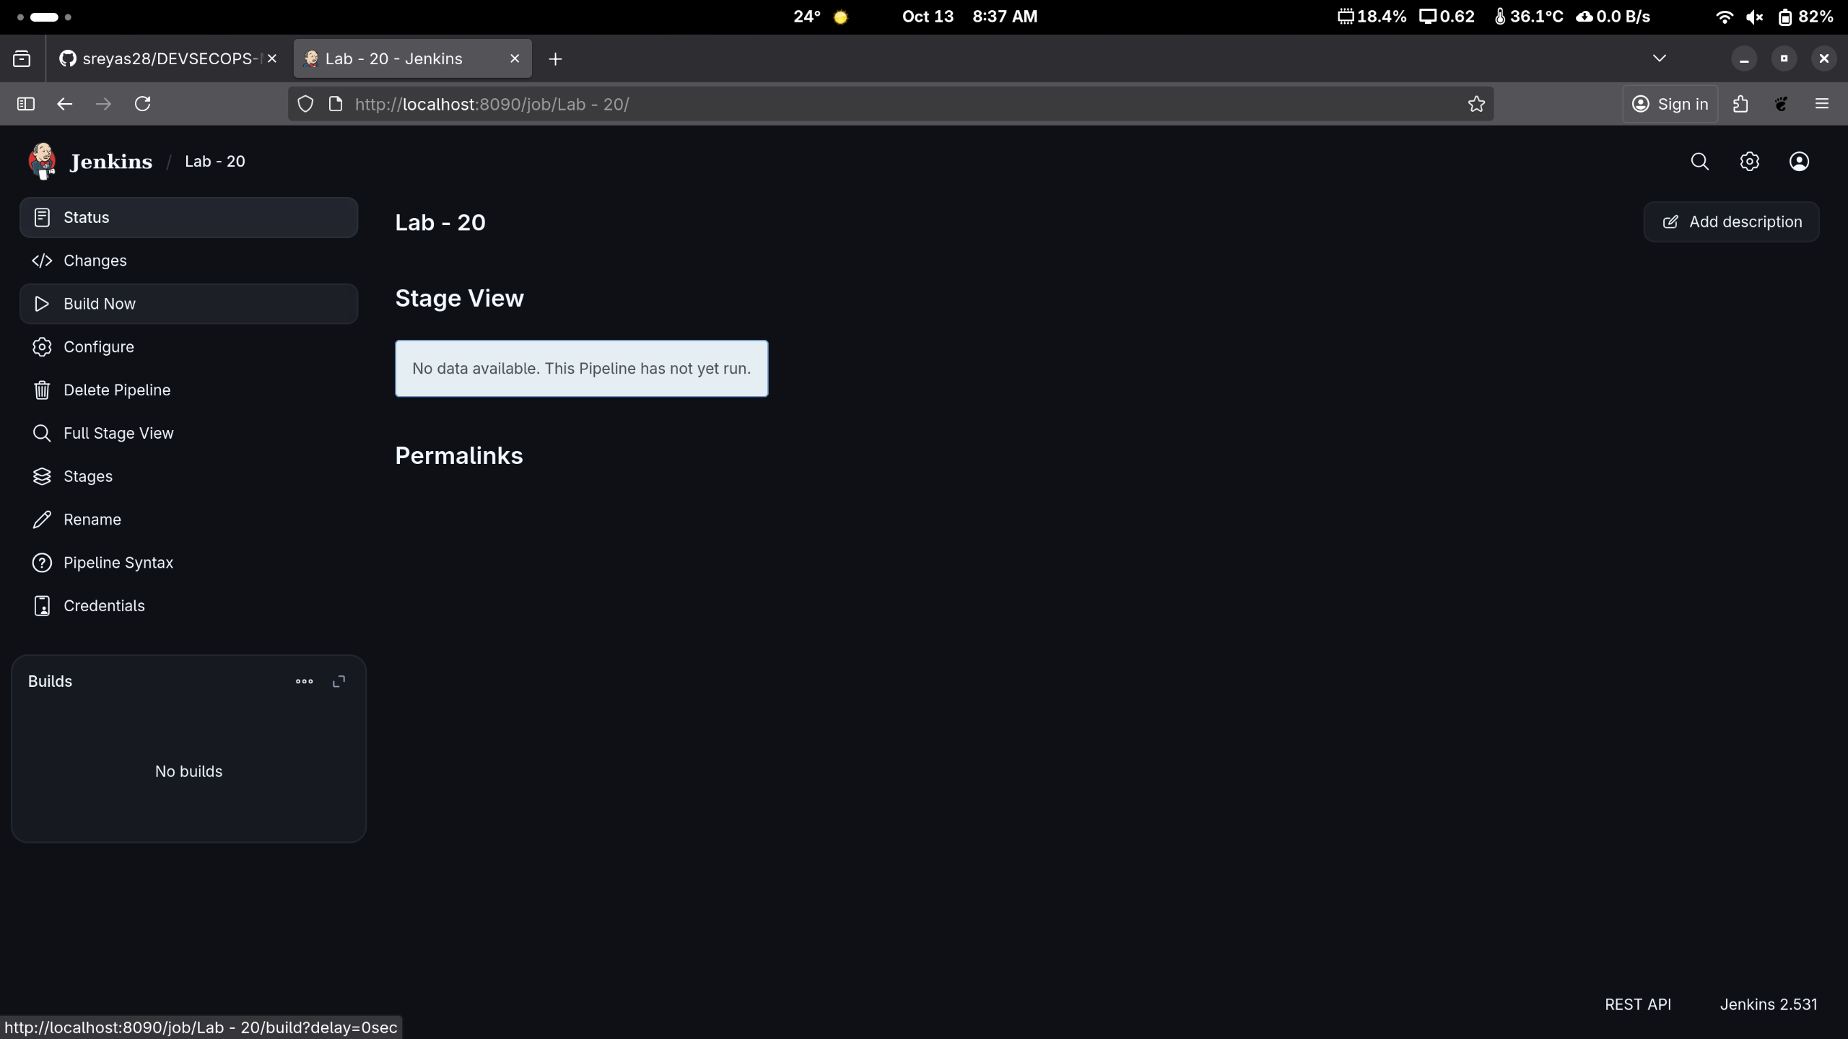

Hover over the milliseconds number next to the build stage name as shown in the screenshot below:

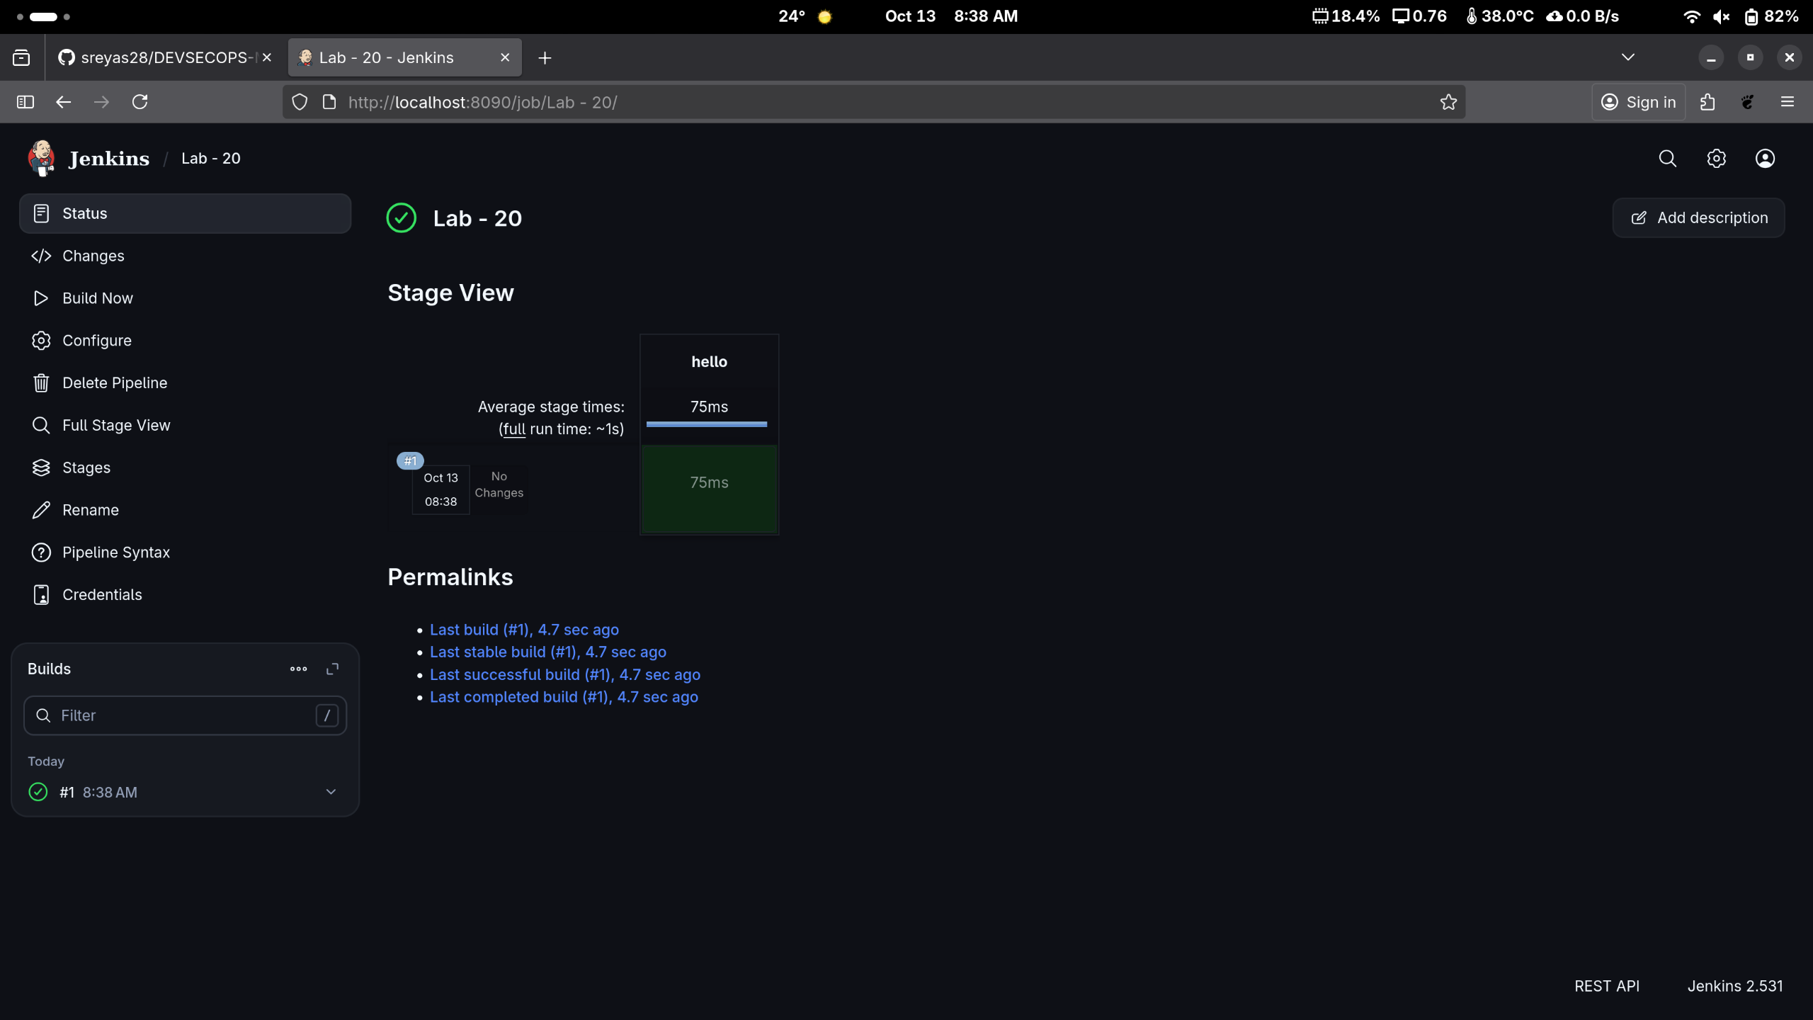

Note: Ensure that you hover the cursor over the milliseconds number without clicking on it

- Click on Logs as shown in the screenshot below:

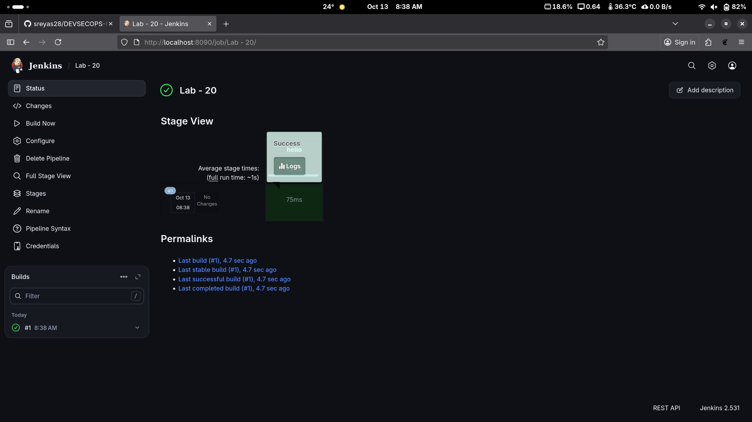

Check for the message in the top-left corner to confirm the successful execution of the pipeline stage as shown in the screenshot below:

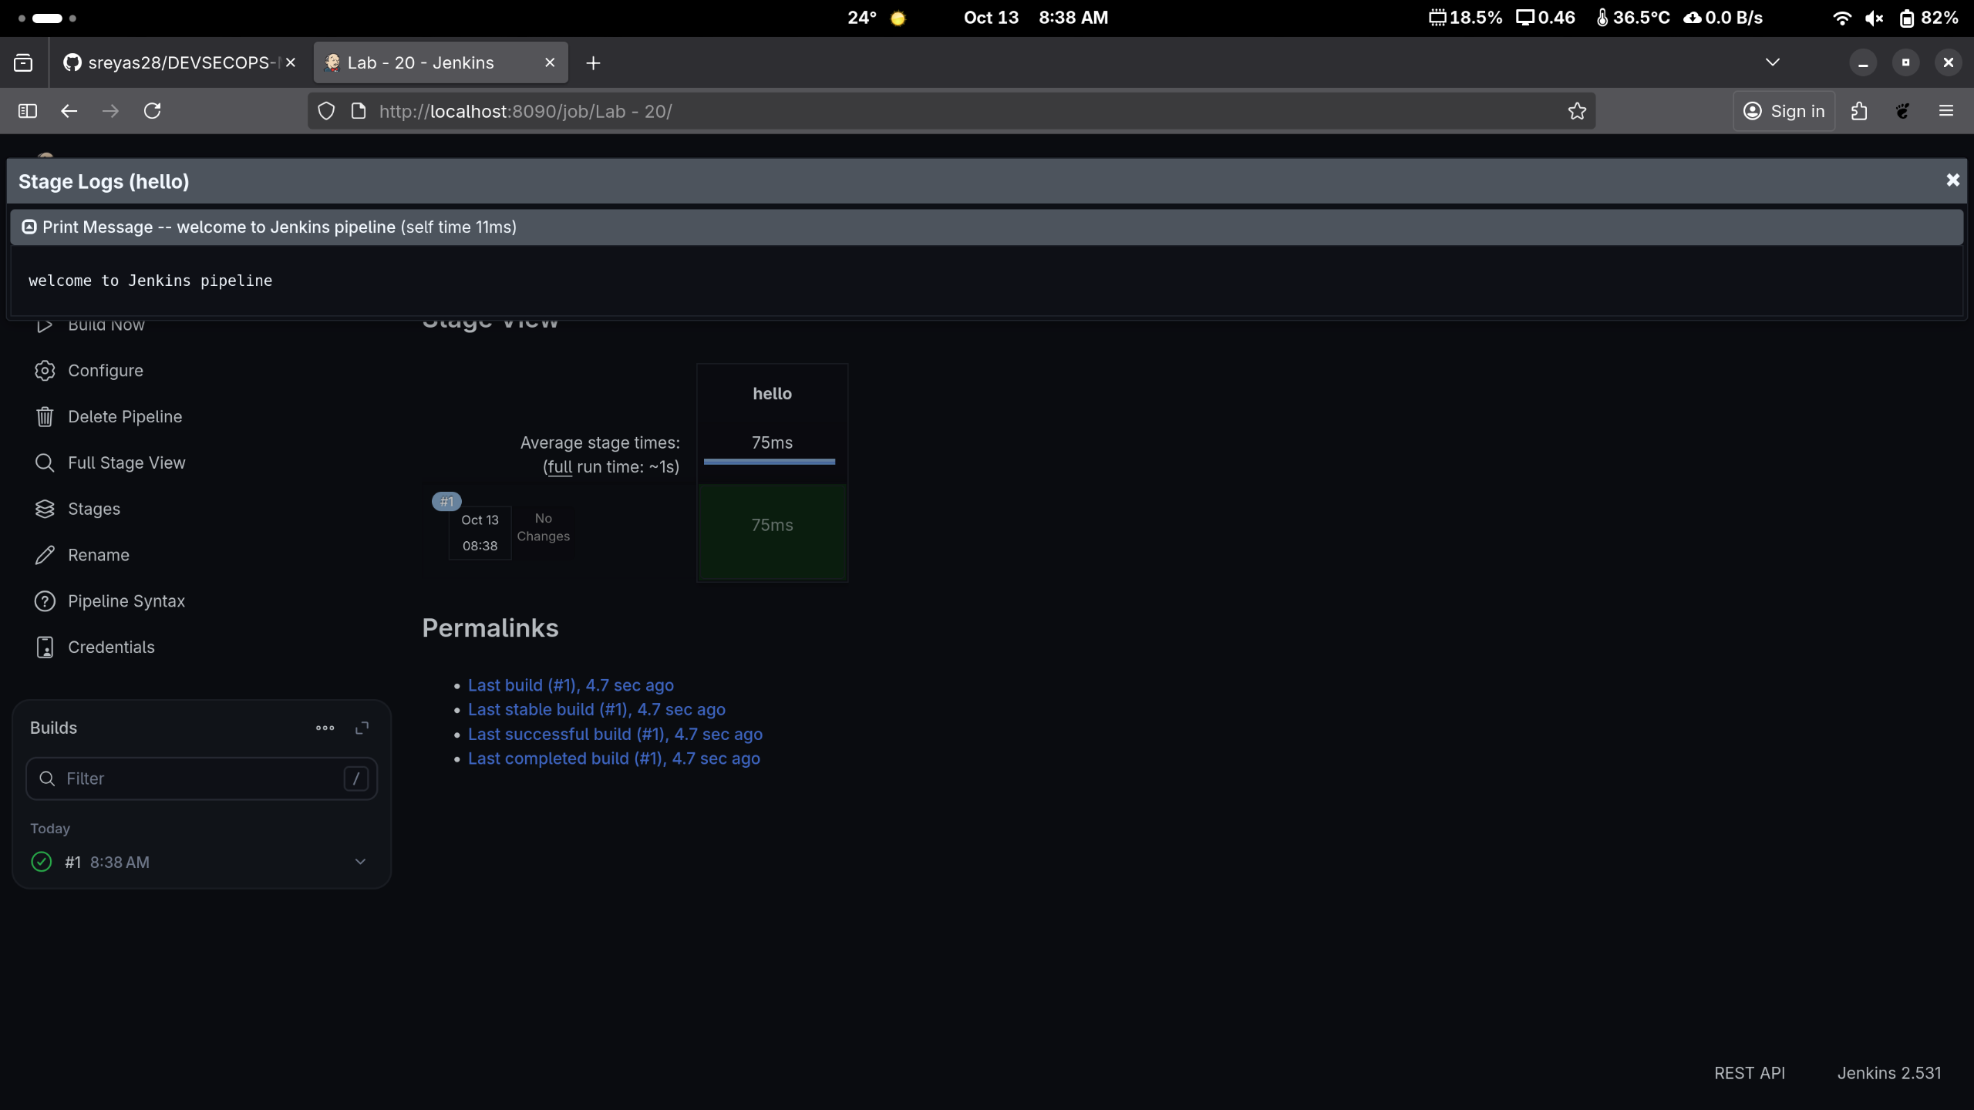

By following these steps, you have successfully created a pipeline script for automating build processes in Jenkins.
To Create a Pipeline Using A script from SCM.

Step:1 Make a New Job Using PipeLine type
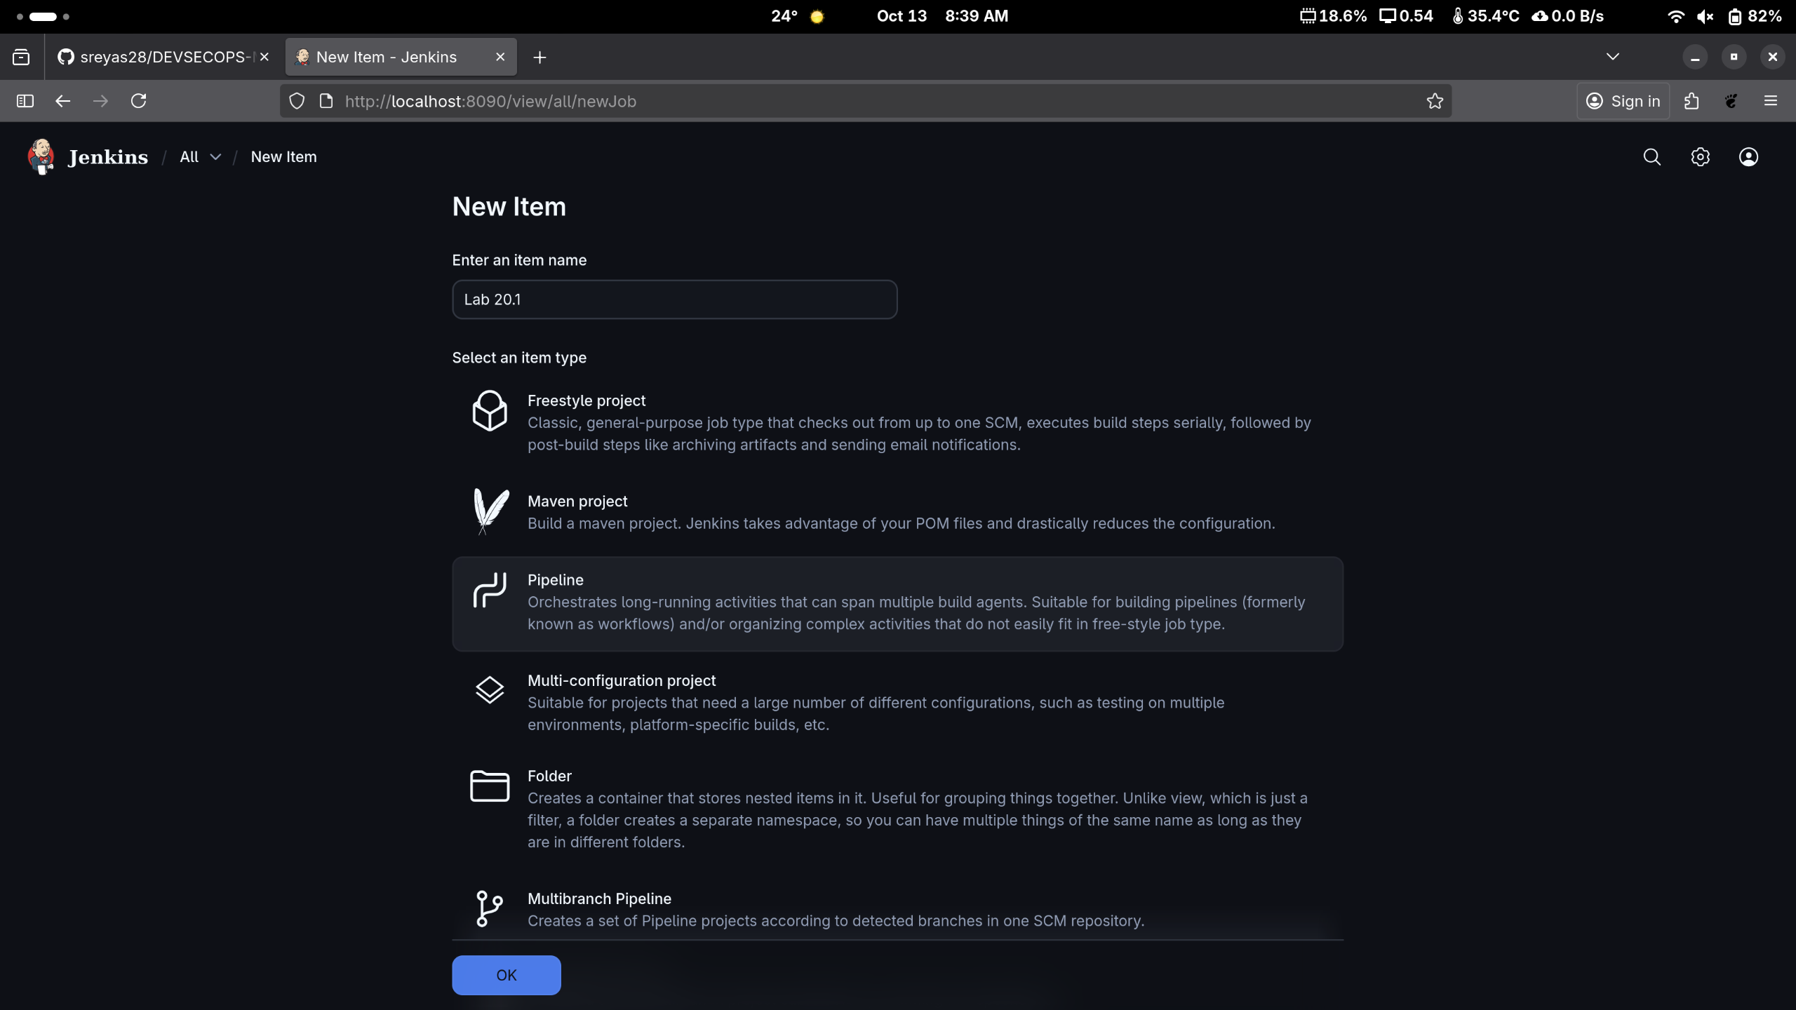

Step:2 Copy the Url of The GitRepo for Next steps.
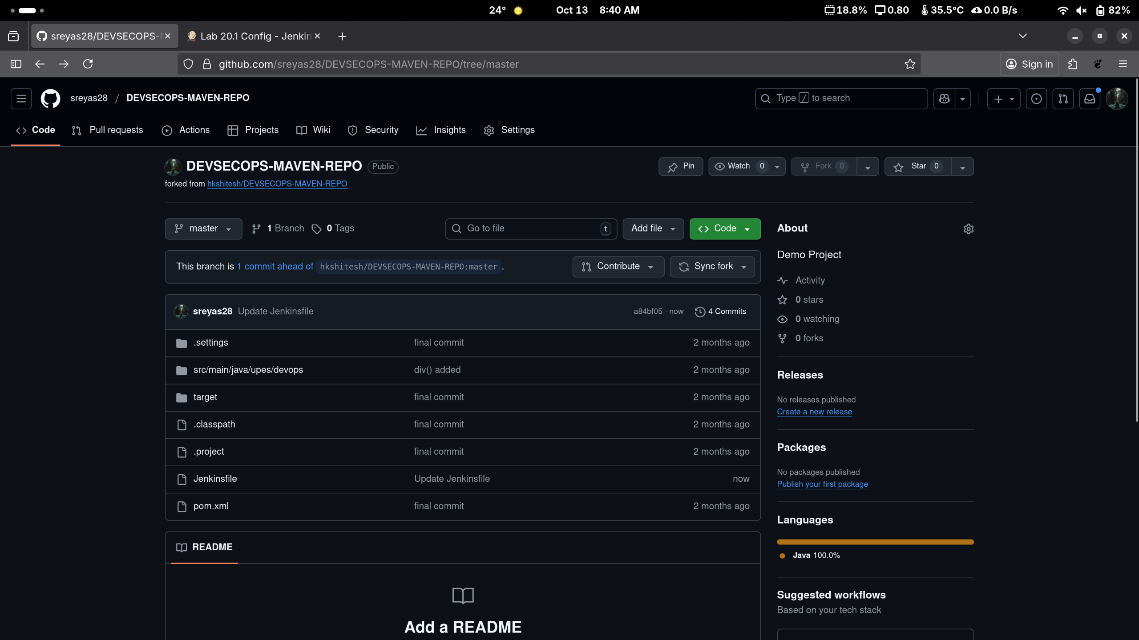
Step 2.1 JenkinsFile Contains following Things.
pipeline
{
agent any
tools
{
maven 'Maven_Home'
}

stages
{
stage('Welcome Stage')
{
steps
{
echo 'Welcome to Jenkins Pipeline'
}
}

stage('Clean Stage')
{
steps
{
sh 'mvn clean'
}
}
stage('Clean Success Stage')
{
steps
{
echo 'clean success'
}
}
stage('Build & Install Stage')
{
steps
{
sh 'mvn install'
}
}

stage('Build Success')
{
steps
{
echo 'Build successful'
}
}

}
}

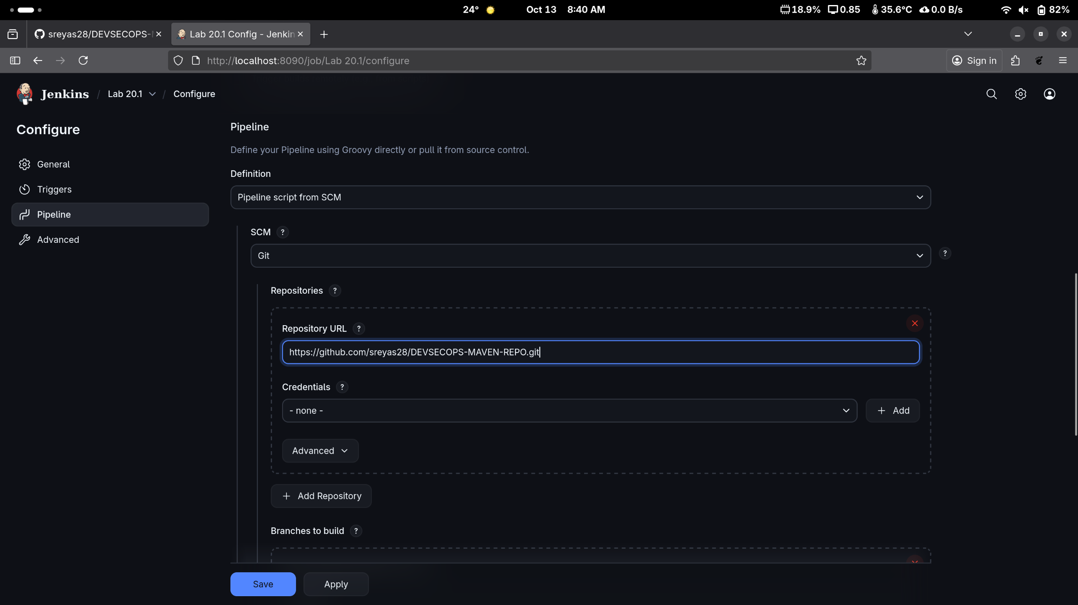
Step:3 Select “PipeLine Script From SCM” in defination then Select Git And then Paste The URL.

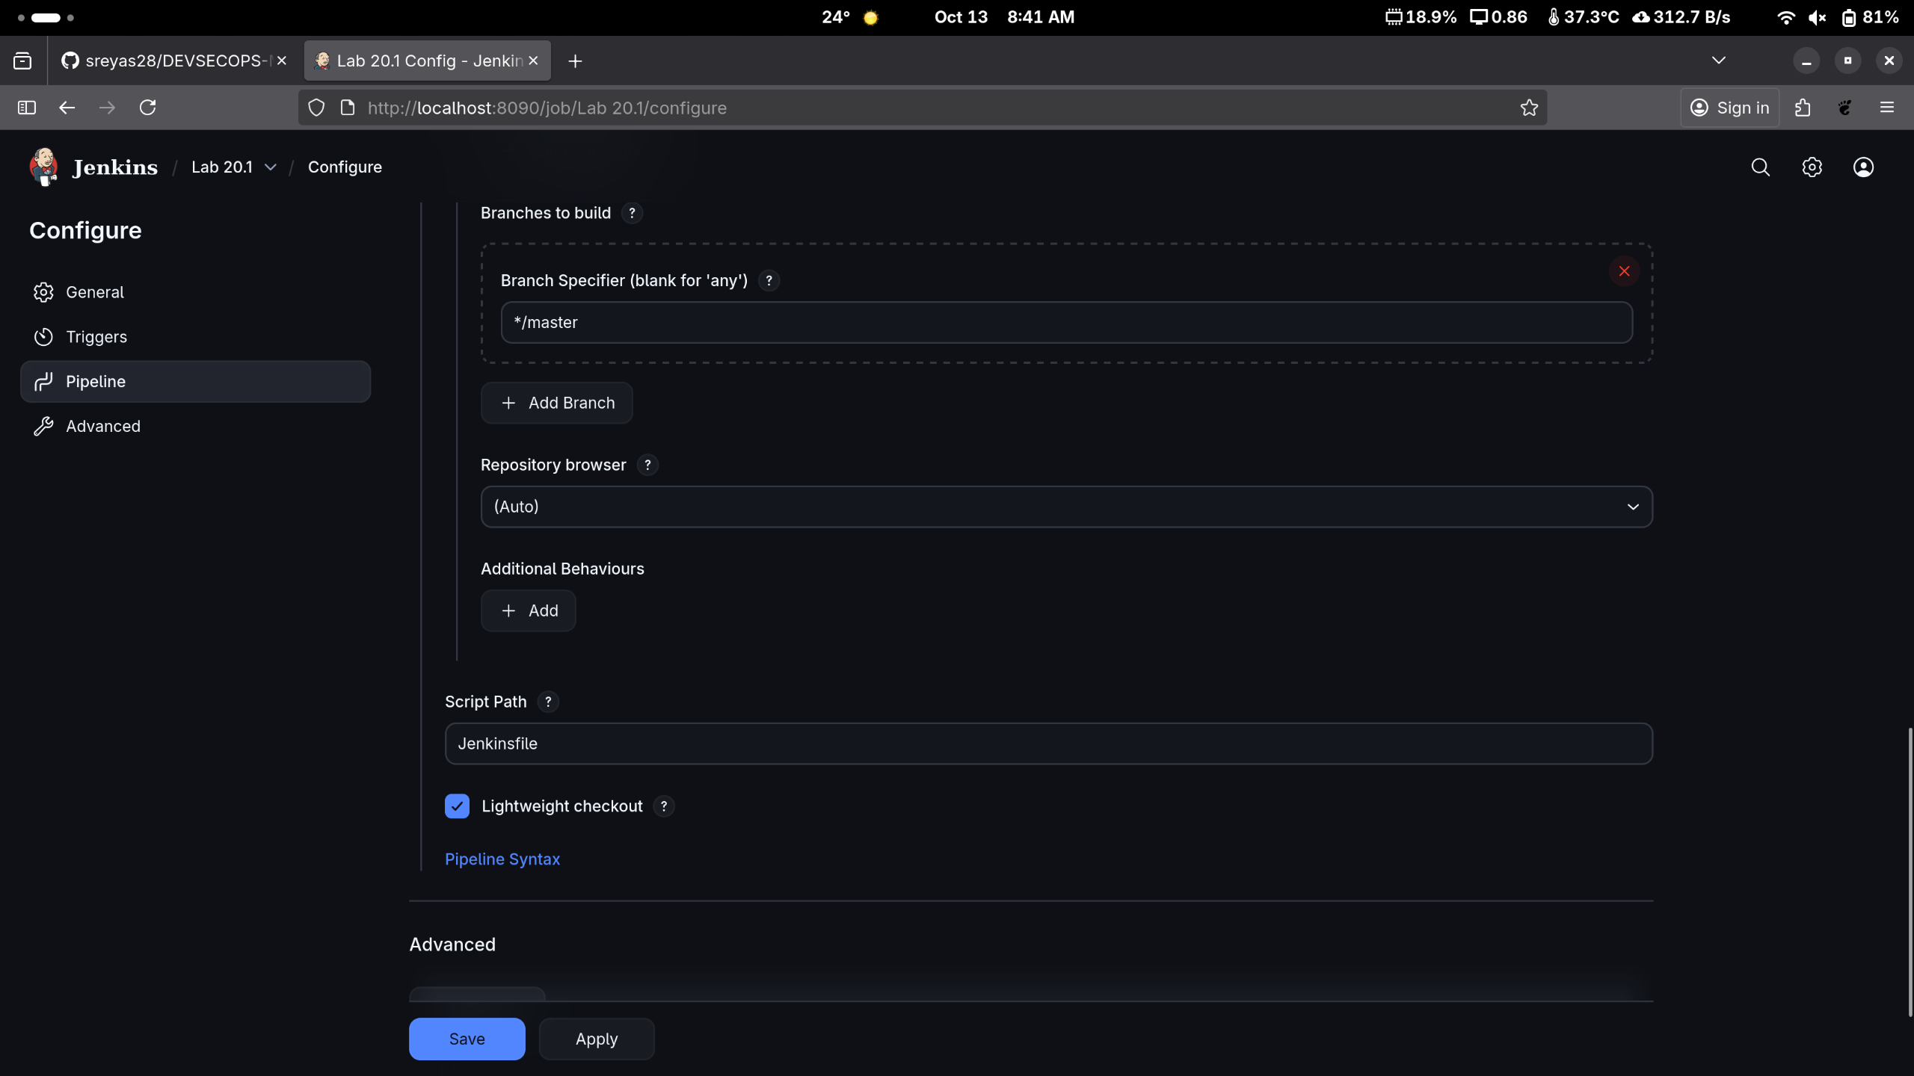
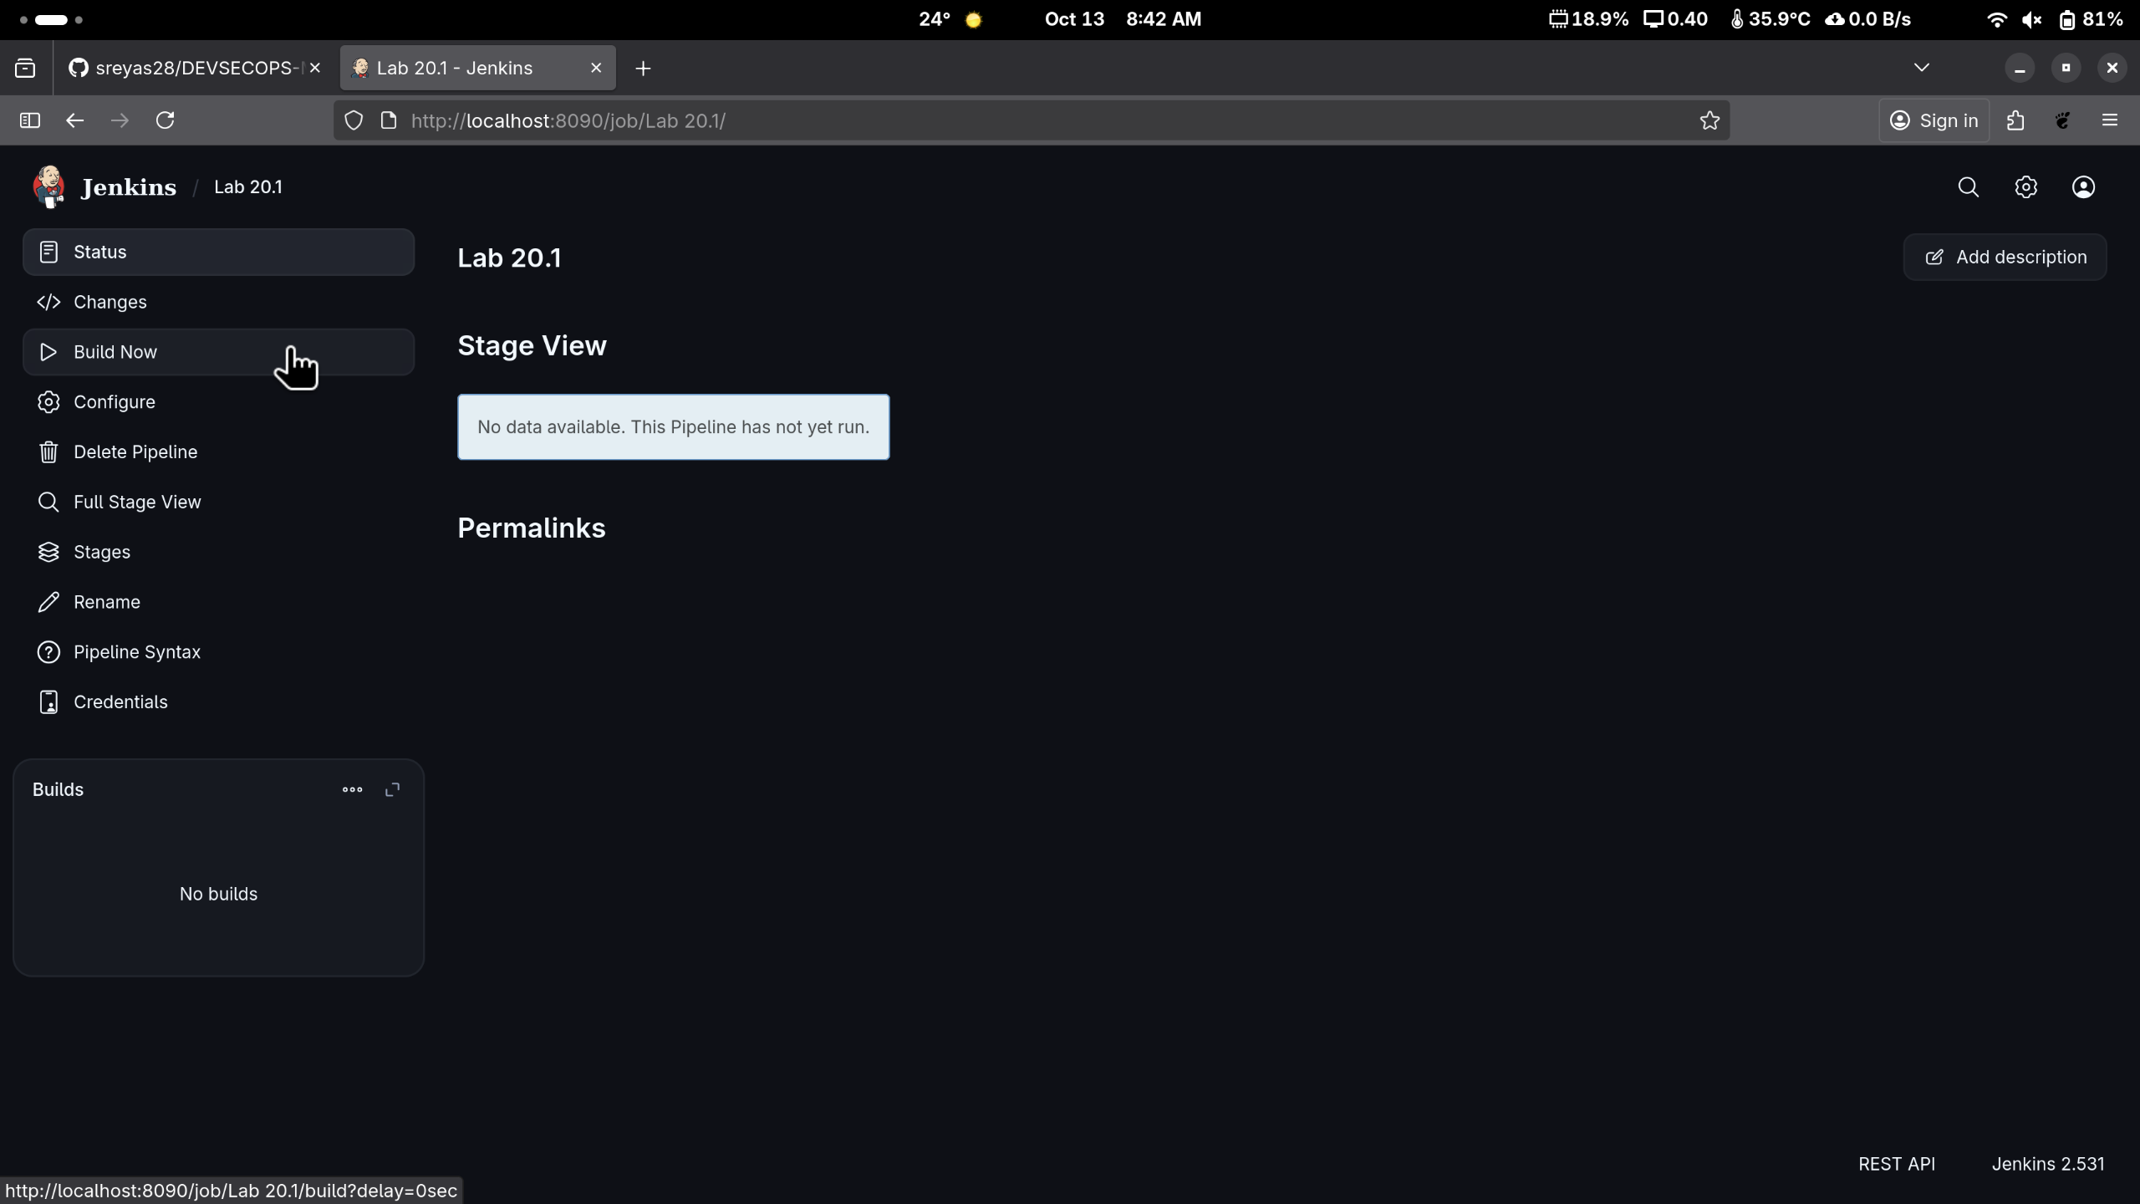
Step:4 after Clicking Save Click on “Build Now”.

Step:5 Now you see The Pipeline doing the thing.
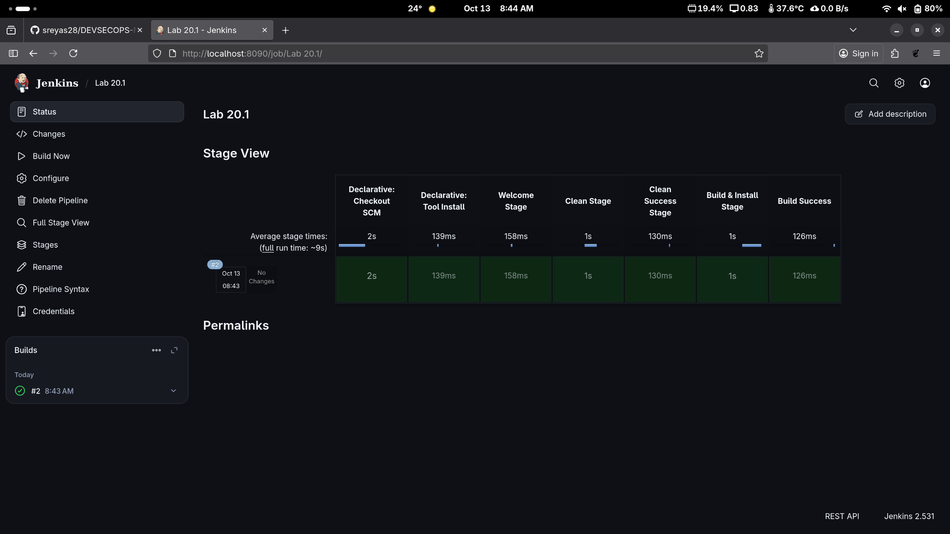
Step: 6 (Optional) Setting up Poll SCM. Now it will fetch changes from the SCM in every minutes

